**Res-TrackR: An IoT Based Emergency Tracking System**

*by*

|  |  |  |
| --- | --- | --- |
| Name | University Roll No. | Registration No: |
| **Kuntal Paul** | **11700318092** | **181170110290 OF**  **2018-2019** |
| **Arpan Mukherjee** | **11700318114** | **181170110268 OF**  **20182019** |
| **Debadrita Debnath** | **11700318104** | **181170110278 OF 2018-2019** |

*A comprehensive project report has been submitted in partial fulfillment of*

*the requirements for the degree of*

**Bachelor of Technology**

*in*

**ELECTRONICS & COMMUNICATION ENGINEERING**

*Under the supervision of*

**Dr. Tiya Dey Malakar**

Assistant /Associate / Professor



**Department of Electronics & Communication Engineering**

**RCC INSTITUTE OF INFORMATION TECHNOLOGY**

**Affiliated to Maulana Abul Kalam Azad University of Technology, West Bengal**

**CANAL SOUTH ROAD, BELIAGHATA, KOLKATA – 700015**

**June, 2022**

**CERTIFICATE OF APPROVAL**



This is to certify that the project titled “**Res-TrackR: An IoT Based Emergency Tracking System**” carried out by

|  |  |  |
| --- | --- | --- |
| Name | Roll No. | Registration No: |
| **Kuntal Paul** | **11700318092** | **181170110290 OF**  **2018-2019** |
| **Arpan Mukherjee** | **11700318114** | **181170110268 OF 2018-2019** |
| **Debadrita Debnath** | **11700318104** | **181170110278 OF 2018-2019** |

|  |  |
| --- | --- |
| Optional in case of External Supervisor  .........................................................  **Dr./Mr./Ms./Mrs. XXXXX XXXXX**  Designation and Department  Institute | .........................................................  **Dr. Tiya Dey Malakar**  Professor , Dept. of ECE  RCC Institute of Information Technology |

for the partial fulfillment of the requirements for B.Tech degree in **Electronics and Communication Engineering** from **Maulana Abul Kalam Azad University of Technology, West Bengal** is absolutely based on his own work under the supervision of Dr. **Tiya Dey Malakar**. The contents of this thesis, in full or in parts, have not been submitted to any other Institute or University for the award of any degree or diploma.

..........................................................

**Mr. Ashoke Mondal**

Head of the Department (ECE)

RCC Institute of Information Technology

**DECLARATION**



“We Do hereby declare that this submission is our own work conformed to the norms and guidelines given in the Ethical Code of Conduct of the Institute and that, to the best of our knowledge and belief, it contains no material previously written by another neither person nor material (data, theoretical analysis, figures, and text) which has been accepted for the award of any other degree or diploma of the university or other institute of higher learning, except where due acknowledgement has been made in the text.”

|  |  |
| --- | --- |
| ……...........................................................  **Kuntal Paul**  Registration No: 181170110290 OF 2018-2019  Roll No: 11700318092 | ...........................................................  **Arpan Mukherjee**  Registration No: 181170110268 OF 2018-2019  Roll No: 11700318114 |
|  | ...........................................................  **Debadrita Debnath**  Registration No: 181170110278 OF 2018-2019  Roll No: 11700318104 |

Date:

Place: Kolkata

**CERTIFICATE of ACCEPTANCE**



This is to certify that the project titled “**Res-TrackR: An IoT Based Emergency Tracking System**” carried out by

|  |  |  |
| --- | --- | --- |
| Name | Roll No. | Registration No: |
| **Kuntal Paul** | **11700318092** | **181170110290 OF 2018-2019** |
| **Arpan Mukherjee** | **11700318114** | **181170110268 OF 2018-2019** |
| **Debadrita Debnath** | **11700318104** | **181170110278 OF 2018-2019** |

is hereby recommended to be accepted for the partial fulfillment of the requirements for B.Tech degree in **Electronics and Communication Engineering** from **Maulana Abul Kalam Azad University of Technology, West Bengal**

**Name of the Examiner Signature with Date**

1. …………………………………………………………………

2. ……………………………………..…………………………...

3. …………………………………………………………………

4. …………………………………….……………………………

ABSTRACT

Women’s safety plays a very vital role now a days due to rising crimes against women.

In light of the present situation of the cities and other big cities, women security has emerged as one of the most important requirement in our country. In 21st century where the technology is rapidly growing and smart electronics gadgets are being developed but still women and girls are facing problem. It is an unfortunate observation that there has been a substantial increase in crimes against women in the past decade. Women don’t seem to be safe anywhere and are most vulnerable when traveling alone into lonely roads and deserted places. Research in developed and developing countries suggest that women are more dependent on public transport as compared to men and women often encounter violence and harassment in public transport. Also right now nearly of the general population having an own vehicle, robbery is occurring on parking.

So, in this project we have planned to propose a device which will act as a tool to provide security and ensures the safety of the women and the children. This device can also track the location of a vehicle. . In today's world, already IoT has become a technological key player in multiple solutions. Taking this one step higher, to solve one of the burning problems of the society, RES-TRACKR: AN IOT BASED EMERGENCY TRACKING SYSTEM is proposed here. As the name suggests, it is basically a Rescue Tracker Device, incorporated with IoT, which can report user's location upon user's consent. A GPS system is used to trace the current position of the victim and a GSM modem is used to send the message to the pre-defined numbers. It has been prioritized to give security to women especially to the women in urban areas as they can face problems while travelling.

CONTENTS

|  |  |  |
| --- | --- | --- |
| **CERTIFICATE Error: Reference source not found OF APPROVAL** | **……………………………………………………** | **2** |
| **DECLARATION PAGEREF _Toc360457110 \hError: Reference source not found** | **……………………………………………………** | **3** |
| **CERTIFICATE OF ACCEPTANCE** | **……………………………………………………** | **4** |
| **ABSTRACT PAGEREF _Toc360457109 \h5** | **……………………………………………………** | **5** |
| **CONTENTS PAGEREF _Toc360457111 \hError: Reference source not found** | **……………………………………………………** | **6** |
| **LIST OF ABBREVIATIONS** | **……………………………………………………** | **7** |
| **LIST OF FIGURES** | **……………………………………………………** | **8** |
| **LIST OF TABLES** | **……………………………………………………** | **9** |
| **INTRODUCTION PAGEREF _Toc360457116 \hError: Reference source not found** | **……………………………………………………** | **10** |
| **PROBLEM STATEMENT PAGEREF _Toc360457118 \hError: Reference source not found** | **……………………………………………………** | **12** |
| **RELATED WORKS** | **……………………………………………………** | **12** |
| **AIM** | **……………………………………………………** | **15** |
| **METHODOLOGY** | **……………………………………………………** | **15** |
| **IOT ARCHITECTURE** | **……………………………………………………** | **16** |
| **HARDWARE** | **……………………………………………………** | **17** |
| **SOFTWARE** | **……………………………………………………** | **25** |
| **DEPLOYMENT AND RESULTS** | **……………………………………………………** | **26** |
| **FUTURE SCOPE** | **……………………………………………………** | **28** |
| **CONCLUSION** | **……………………………………………………** | **28** |
| **REFERENCE** | **……………………………………………………** | **29** |

LIST OF ABBREVIATIONS

|  |  |
| --- | --- |
| IoT | Internet of Things |
| GPS | Global Positioning System |
| GSM | Global System for Mobile Communication |
| PCB | Printed Circuit Board |
|  |  |
|  |  |
|  |  |

LIST OF FIGURES

|  |  |  |
| --- | --- | --- |
| **Figure No.** | **Figure Name** | **Page No.** |
| Fig 1(a) | Circuit Diagram of Res-TrackR | 16 |
| Fig 1(b) | PCB Design of the circuit of Res-TrackR | 16 |
| Fig 2 | ESP8266 NodeMCU CP2102 Development Board | 18 |
| Fig 3 | ESP8266 NodeMCU CP2102 Development Board Components | 19 |
| Fig 4 | NEO6MV2 GPS Module | 20 |
| Fig 5 | NEO6MV2 GPS Module Components | 21 |
| Fig 6 | SIM900 GSM/GPRS Module | 22 |
| Fig 7 | SIM900 GSM/GPRS Module Components | 23 |
| Fig 8 | TTP223 Touch Sensor Module | 24 |
| Fig 9 | TTP223 Touch Sensor Module Components | 24 |
| Fig 10 | Flowchart of algorithm used in Res-TrackR | 26 |
| Fig 11 | Deployment Model of Res-TrackR | 27 |
| Fig 12(a) | SMS sent by GSM with Google Map Link | 27 |
| Fig 12(b) | Google Map view of the location | 27 |

LIST OF TABLES

|  |  |  |
| --- | --- | --- |
| **Table No.** | **Table Name** | **Page No.** |
| Table 1 | Main Components used in RES-TRACKR | 17 |

1. **INTRODUCTION**

Security is the condition of being protected against danger or loss. In the general sense, security is a concept similar to safety. The nuance between the two is an added emphasis on being protected from dangers that originate from outside. Individuals or actions that encroach upon the condition of protection are responsible for the breach of security. The word "security" in general usage is synonymous with "safety," but as a technical term "security" means that something not only is secure but that it has been secured. Women safety has always been a difficulty even in these present with such a lot advancement in technology. It is an unfortunate observation that there has been a substantial increase in crimes against women in the past decade. With a variety of software applications now in action, to help women, the statistics have not lowered. Many preventive measures have been taken by the government to stop these misbehaving activities but still have not affected the growing rate of these crimes and have remained unaffected.

The crimes are increasing in India as it was 195,856 in year 2008 and went up to 244,270 in 2012. The instances of wrongdoing against women have totaled to 327,394, as announced in 2015. Even in this modern era women are feeling insecure to step out of their house because of increasing crimes in our country like harassment, abuse, violence etc. The corporate and IT sector are currently in boom. Many women are working in corporate even in night shifts. There is a feeling of insecurity among the working women. Overall 86% of working women in India, women facing hurdles are high in Delhi, Mumbai, Hyderabad, Kolkata and Pune comparatively to other places. Most of the attacks on women happen once they are travelling alone or are in a very remote area where they’re ineffectual to seek any help or proper assistance.

The challenging problem faced by the women in the modern world is their security. They do not have complete independence and security in their everyday life. They are made to lead their life in constant fear. Many steps have been taken in the field of women security, but

these could not help us from reducing the number of assault against women. There are many laws and regulations against this issue. But something has to be done at grass roots level. This project aims to solve this issue with the help of technology.

The internet today has become the main source for various technological advancement globally. In today's world, already IoT has become a technological key player in multiple solutions. So to help resolve this issue we propose a GPS based safety system. The main objective of this paper is to design and implement a highly reliable system for protecting women from being harassed. This paper is all about providing safety to women on designing the smart device. Taking this one step higher, to solve one of the burning problems of the society, RES-TRACKR: AN IOT BASED EMERGENCY TRACKING SYSTEM is proposed here. As the name suggests, it is basically a Rescue Tracker Device, incorporated with IoT, which can report user's location upon user's consent. This device helps to identify the critical situation of women. Women safety has become major issue in day to day world. Thus in dangerous situations this will act as protecting hand. With further research and innovation, this project can be used as a small wearable device like watch, pendent etc. Implementing real time application and a device, we can solve the problems to an extent.

The purpose of this project is to design an easy and portable device for women safety. The proposed device is more like a safety system in case of emergency. It is an easy to carry device with more features and functions. A GPS system is used to trace the current position of the victim and a GSM modem is used to send the message to the pre-defined numbers.

The basic approach is to intimate instant location and a distress message to the registered mobile numbers like parents, friends, media, and women cell etc. so that unfortunate incidents would be averted and to provide real time evidence for swift action against the perpetrators of crime against women.

1. **PROBLEM STATEMENT**

Women’s security is a critical issue in today’s world and it’s very much needed for every individual to be acting over such an issue. In our country, it has rule and financial betterment, but still there are many abuses against women. Women have the right to be free from violence, harassment and discrimination. Removing the barriers of an unsafe environment can help women fulfill their potential as individuals and as contributors to work, communities and economies. In this world of advanced technology and smart electronics it is required to have a simple and cost-effective safety gadget that helps the victims during unforeseen dangers.

Finally, tools should be introduced to ensure women's protection with different technologies. This paper cover descriptive details about the design and implementation of prototype for an electronic gadget which has the potential to serve as a safety wear in the coming years. This Project is for women's safety system which provides the current location of the women in danger through GSM module. When the system gets activated an alert message is generated and sends to the main control or registered mobile number with the help of GSM module. This system can overcome the fear that scares every woman in the

country about her safety and security.

1. **RELATED WORKS**

The paper by B. Sathyarsi, U. Jaishree Vidhya, G. V. K. Jothi Sree, T. Pratheeba, K. Ragapriya on ‘Design and Implementation of Women Safety System Based On Iot Technology’ where they suggest the creation of a device that combines various devices like GPS module, GSM module, Arduino microcontroller, Buzzer, LCD display, Vibration sensor etc. When a lady detects danger in this endeavour, she must hold the device's trigger ON. When the device is turned on, it uses GPS (Global Positioning System) to track the present location and sends an emergency message via GSM (Global System for Cellphone Communication) to the registered mobile number and a nearby police station. The IoT module is used to continuously track the position and refresh the webpage. In emergency scenarios, the Neuro Stimulator will provide a non-lethal electric shock to detect the attacker; the buzzer will serve as an alarm to warn nearby people, letting them know that someone is in distress; and the vibrating sensor will relay the last location if the gadget malfunctions [1].

The paper by Dr. Shuchi Dave, Vikash Singh, Vishnu Singh, Vishnu Kumawat on ‘WOMEN SAFETY DEVICE BASED ON GPS & GSM’ proposes the design and implementation of an extremely reliable strategy for preventing harassment of women. They have used GSM module, GPS module, Ultrasonic sensor along with video camera, LCD display, alcohol sensor, buzzer etc. and Arduino as a microcontroller. According to this system when the woman presses the button, the entire system will begin to function. The Arduino uno is used to link all of the components, as well as the power supply (battery). The alcohol sensor will detect the opposite person's alcohol levels, while the ultrasonic sensor will detect the distance between the woman and the person. The location of the woman's trouble will be determined through GPS. All of the information, such as distance, position, alcohol concentration, and "I am in difficulty, please assist me," is sent to the registered number through GSM in the form of a message [2].

The paper ‘WOMEN SAFETY DEVICE’ by Yatharth Choudhary, Surbhi Upadhyay, Dr.Rita Jain, Abhishek Chakraborty suggests a Safety Device. A microprocessor, a temperature sensor, a heartbeat sensor, and an emergency pushbutton switch make up the safety gadget. When this device detects an emergency, it retrieves the woman's present location and sends it to emergency contacts using the Global System for Mobile (GSM) module. A bright Light Emitting Diode (LED) flash, a hooter or siren, and a shock giving circuit are also included in the safety gadget, which are designed to injure the attacking or abusing individual, allowing the woman to flee. An interfaced Liquid Crystal Display (LCD) display also shows the heartbeat rate and temperature [3].

Another paper ‘Women safety and security system using GSM and GPS’ by K.Latha, G.Vinay Kumar, P.Naveen, B.Srikanth, K.Vijay srinivas, offers a quick-response mechanism to assist women in times of need. When a harasser presses the button, the location information is sent as an SMS alert to a few predetermined numbers in terms of latitude and longitude [4].

A paper by K. Srinivasan, T. Navaneetha, R. Nivetha, K. Mithun Sugadev on ‘IoT Based Smart Security and Safety System for Women and Children’ proposes a device by which women's current position and notifications are sent to various mobile numbers in their contact list using a microcontroller, GSM, and GPS module. Furthermore, this initiative will serve as a safety measure by temporarily incapacitating the opposition [5].

The paper ‘WOMEN SAFETY DEVICE WITH GPS, GSM AND HEALTH MONITORING SYSTEM’ by Nishigandha Kale, Komal Hadke, Mayuri Kadam, Kanchan Nale This study describes the design and development of a prototype for an electronic device that has the potential to act as a safety wear in the future. A switch, Arduino (Node MCU), GPS module (Neo6M), buzzer, temperature sensor, and pulse sensor make up the device. The fundamental idea behind this invention is that whenever a woman feels threatened, all she has to do is press the device's button. When the device is turned on, it uses GPS (global positioning system) to track the women's whereabouts and sends emergency alerts via GSM (global system for mobile communication) to previously registered mobile numbers and the police control room [6].

Another paper by Dr. C. K. Gomathy, Mr. R. Lakshmi Kartheek Kumar Reddy, Mr. S. Sai Krishna Chaitanya on ‘WOMEN SAFETY BASED ON GPS CONTROL’ where as a result, they advocated the use of stun guns. When the panic key is touched, the boost circuit uses GPS to deliver a powerful shock pulse to the stranger at the same time. The woman's current location will be communicated to the police department via the registered phone numbers [7].

Another paper on ‘Implementation of Car Tracking System using GSM/GPS’ by Engr. Nwukor Frances Nkem has the major goal to design and create a car mobilizer and demobilizer system that works in real time. The user can send a command from his smart phone to the GSM module, which causes the module to check for the user's authentication and, if found to be legitimate, provide the location's details, such as the latitude and therefore the longitude, using the GPS module. As a result, the user can learn the specific position of the vehicle marked on Google Maps. A user can also command the car to be demobilized or mobilized [8].

1. **AIM**

This is a system that is provided for women's security purposes. Even in this modern era women are feeling insecure to step out of their house because of increasing crimes in our country like harassment, abuse, violence etc. The main purpose of this this project is to help women whenever they are in emergency or in any danger.

It is an easy to carry device with more features and functions. By using this system a user can get quick and immediate help in any emergency situation. The System refers the Global Positioning System to trace out the position of the person and uses the Messaging service to send the message to get the help.

* To fetch the current position of user (latitude and longitude) with higher accuracy.
* To send the location in a Google Map link through a SMS to a particular device whenever the touch sensor senses a touch (gets triggered).
* Faster and smarter process to track the position of the system user or victim.
* Reducing time and human effort in tracking and rescuing process.

1. **METHODOLOGY**

When a woman finds herself in a wrong situation she has to turn ON the device. We have used a GPS System to trace the current position of the victim and GSM modem is used to send the message to the pre-defined numbers. Basically, this system runs on a simple workflow of Fetch-Trigger-Respond. The user provides a trigger by touching into the touch sensor. It serves as an Interrupt to the normalcy of the system. As an interrupt requires ISR (Interrupt Service Routine), in a similar fashion, this trigger asks the device to fetch current Location Co-ordinates. If a valid set of coordinates fetched, then the system calls the GSM Module to send an SMS to a registered mobile number with the location details with a Google Map Link.

In this way, this system can potentially be used as a Women-Safety SOS Device, as this IoT device uses the bandwidth of Cellular Communication, it can be used in remote areas also, where internet connectivity is little. Thus, not only as a Women's Safety device, it can be potentially used for any rescue location device also. Such device can be used by campers, and even by rescue officials. So it is a simple and easy to carry device with wide range of features and functionality.

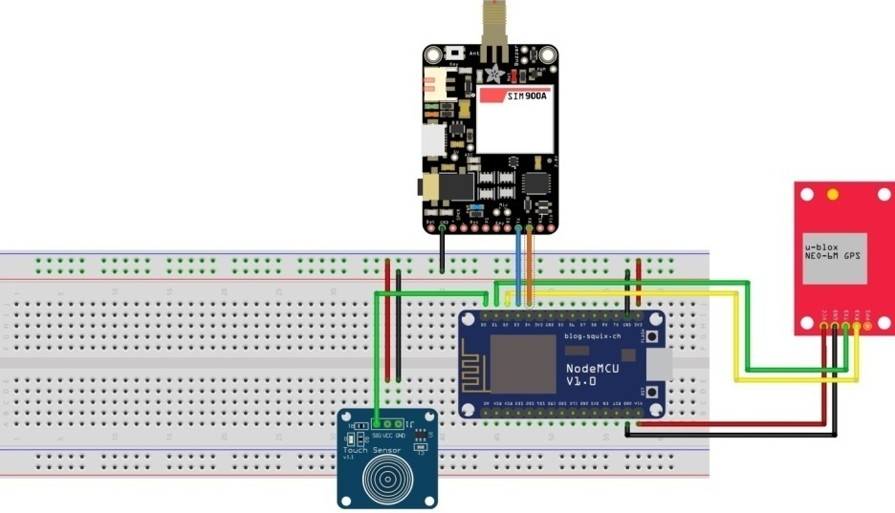 ­­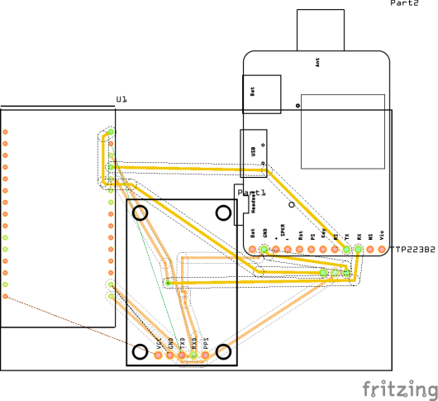

**Fig 1:** (a) Circuit Diagram of Res-TrackR (b) PCB Design of the circuit of Res-TrackR

1. **IOT ARCHITECTURE**

The Res-TrackR system has the **Fetch-Trigger-Respond** architecture.

* 1. **Fetch:** The GPS Module (NEO6MV2) constantly fetches the location coordinates of the current location directly from the satellite via specific radio frequencies when the device is powered ON. These values of latitude and longitude are stored in the flash memory of the ESP8266 microcontroller.
  2. **Trigger:** The Touch sensor is used for triggering. The user touches the touch-pad of the sensor and a HIGH signal is sent to the corresponding pin of the microcontroller as a trigger.
  3. **Respond:** The microcontroller receives the HIGH input from the touch sensor as a trigger and it sends an SMS to a registered mobile number with a alert message and the Google Map link indicating the current location, by the GSM Module through the established cellular network.

**7. HARDWARE**

The RES-TRACKR system contains few hardware components like microcontroller, GPS module, GSM module and touch sensor etc. So, we can make a table of used hardware components in RES-TRACKR.

**Table 1: Main Components used in RES-TRACKR**

|  |  |  |  |
| --- | --- | --- | --- |
| Serial No. | Component Name | Description | Quantity |
| 1 | ESP8266 NodeMCU CP102 Development Board | Microcontroller Unit | 1 (for each node) |
| 2 | NEO6MV2 GPS Module with Flight Controller | GPS Transponder Module (NEO 6M) | 1 (for each node) |
| 3 | SIM900 GSM/GPRS Module | GSM Module for establishing connection | 1 (for each node) |
| 4 | TTP223 Touch Sensor Module | One Channel Capacitive Touch Sensor Module | 1 (for each node) |

Now, we will take a detailed look on the main used components in Res-TrackR.

**7.1. Microcontroller Unit:**

The NodeMCU ESP8266 is an open-source Lua-based firmware and development board designed specifically for Internet of Things (IoT) applications. It includes firmware based on Espressif Systems' ESP8266 Wi-Fi SoC and hardware based on the ESP-12 module, and it, like this, can be programmed using the Arduino IDE and may operate as a WiFi Hotspot or connect to one. It features one analogue input pin, 16 digital I/O pins, and may connect to serial communication protocols such as SPI, UART, and I2C. To store data and programs, the NodeMCU contains 128 KB of RAM and 4MB of Flash memory. It is perfect for IoT projects due to its high processing power, built-in Wi-Fi / Bluetooth, and Deep Sleep Operating capabilities. Prototyping for IoT devices, low-power battery-operated applications, and projects requiring an I/O interface with Bluetooth and WiFi capabilities are just a few of its uses [13].

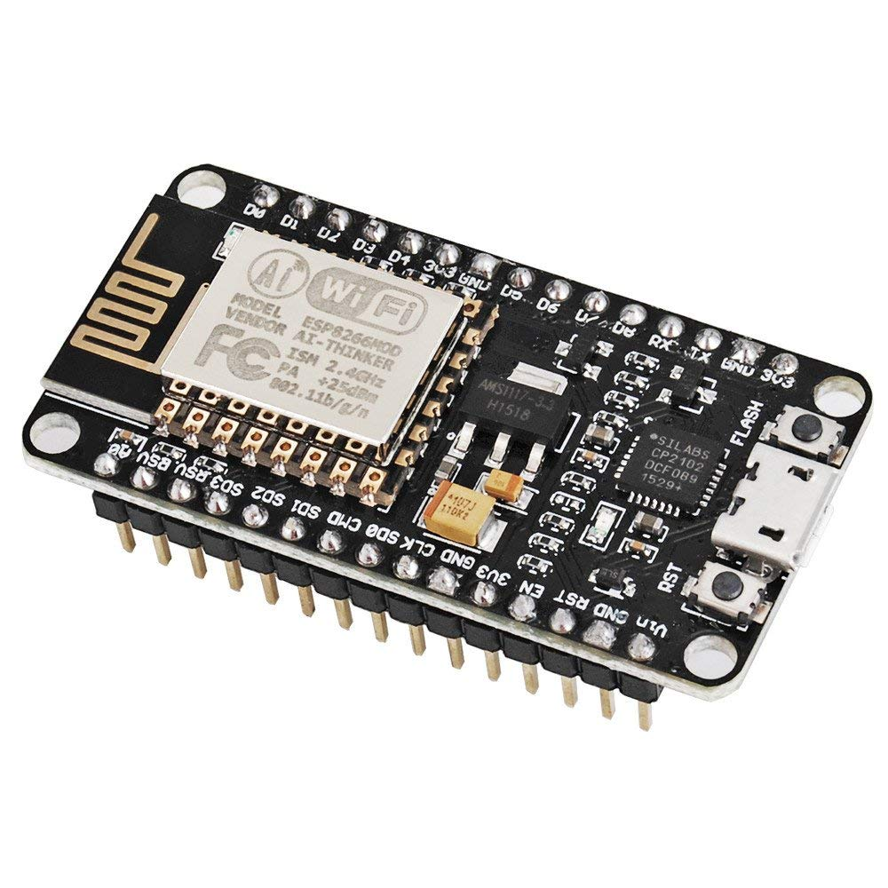

**Fig 2:** ESP8266 NodeMCU CP2102 Development Board

**Technical Specifications of ESP8266 NodeMCU CP2102 Development Board:**

* Microcontroller chip: Tensilica 32-bit RISC CPU Xtensa LX106
* Operational Voltage: 3.3V
* Input Voltage: 7-12V
* I/O Pins (Digital): 16
* I/O Pins (Analog): 1
* UARTs: 1
* SPIs: 1
* I2Cs: 1
* Flash Memory: 4 Mb
* SRAM: 64 KB
* Clock Frequency: 80 MHz

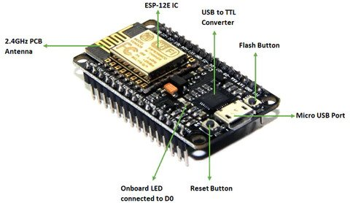

**Fig 3:** ESP8266 NodeMCU CP2102 Development Board Components

The Arduino IDE can simply program the NodeMCU development board; all we need is a micro USB cable to connect to our computer. Learn how to program our NodeMCU Development board and get started with our NodeMCU lesson.

**7.2. GPS Module:**

The NEO-6MV2 is a stand-alone GPS (Global Positioning System) module with a high-performance U-Blox 6 positioning engine with 50 channels. The NEO6MV2 GPS module checks for location on Earth and returns the position's Latitude and Longitude. This is a low-cost module featuring a detachable antenna, as well as a logic level converter and a voltage regulator, making it compatible with both 5V and 3.3V powered boards, such as the ESP8266 NodeMCU, Arduino Uno, Mega, and Pro Mini. It can be utilized in smart phone and tablet navigation systems, drones, location-based applications, and more [14].

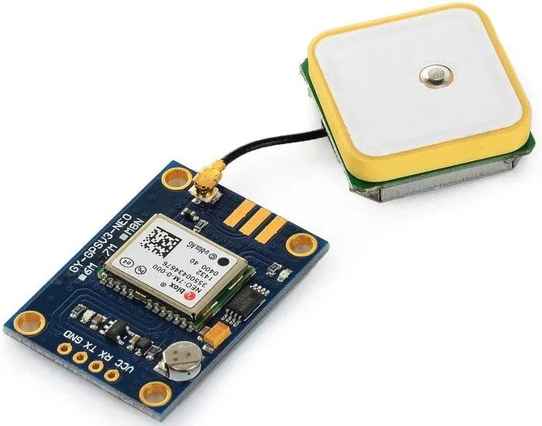

**Fig 4:** NEO6MV2 GPS Module

**Technical Specifications of NEO6MV2 GPS Module:**

* High accuracy and Robust
* Board Dimension: 23mm x 40mm
* Compatibility: 3.3V-5V interface
* Compatible with any version of Arduino, NodeMCU
* EEPROM: In order to save configuration settings
* GPS Antenna Dimension: 18mm x 18mm
* Support SBAS (WAAS, EGNOS, MSAS, GAGAN)
* Maximum navigation update rate: 5Hz
* Baud rate: 9600bps
* EEPROM with battery backup
* Sensitivity:  -160dBm
* Supply voltage: 3.6V
* Operating temperature range: -40ºC TO 85°C

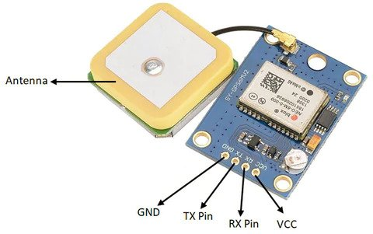

**Fig 5:** NEO6MV2 GPS Module Components

We can either connect our 5V pin or 3.3V pin to VCC and GND to power the gadget. Because it uses UART TTL logic to communicate at 9600 bps, we will need to connect the TX and RX pins on our controller to acquire the GPS coordinates of our location.

**7.3. SIM900 GSM/GPRS Module:**

The GSM-900 GSM/GPRS module is a widely accessible GSM/GPRS module that may link our project to the internet. It can perform all of the functions of a mobile phone, including making and receiving calls, sending and receiving messages, and connecting to the internet via GPRS. We can even use it to converse on our phone calls by connecting a microphone and speaker to it. The SIM900A GSM Module is a dual-band GSM/GPRS engine that operates on the EGSM 900MHz and DCS 1800MHz frequency bands. SIM900A supports the GPRS coding schemes CS-1, CS-2, CS-3, and CS-4 and has GPRS multi-slot class 10/class 8 (optional). This module can be utilized in our IoT and embedded systems applications. Automobiles, robotics, servers, and more applications use this [15].

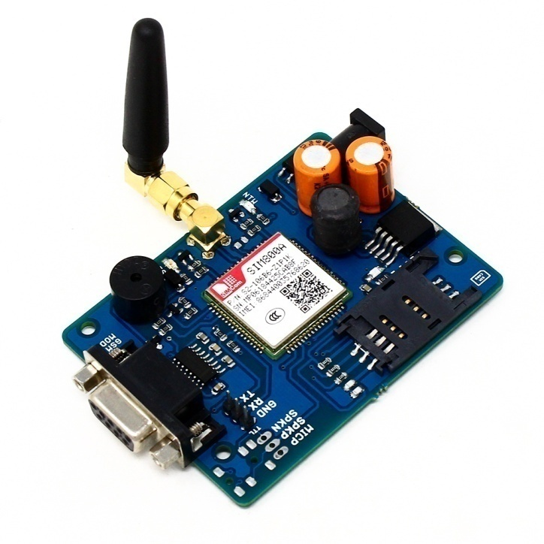

**Fig 6:** SIM900 GSM/GPRS Module

**Technical Specifications of NEO6MV2 GPS Module:**

* Weight: 4.54 gm
* Dimensions: 12.1 x 10.6 x 0.2 cm
* Baud-rate: 1200 to 115200 bps
* Supply voltage: 3.4V – 4.5V
* Power saving mode: Power consumption in SLEEP mode is 1.5mA
* Frequency bands: SIM900A Dual-band: EGSM900, DCS1800. The SIM900A can automatically search the two frequency bands. The AT command can also be used to change the frequency bands.
* GSM class: Small MS
* GPRS connectivity: GPRS multi-slot class 10 (default) , GPRS multi-slot class 8 (option)
* Transmitting power: Class 4 (2W) at EGSM 900, Class 1 (1W) at DCS 1800
* Operating Temperature:- 30ºC to +80ºC
* Storage Temperature:- 5ºC to +90ºC

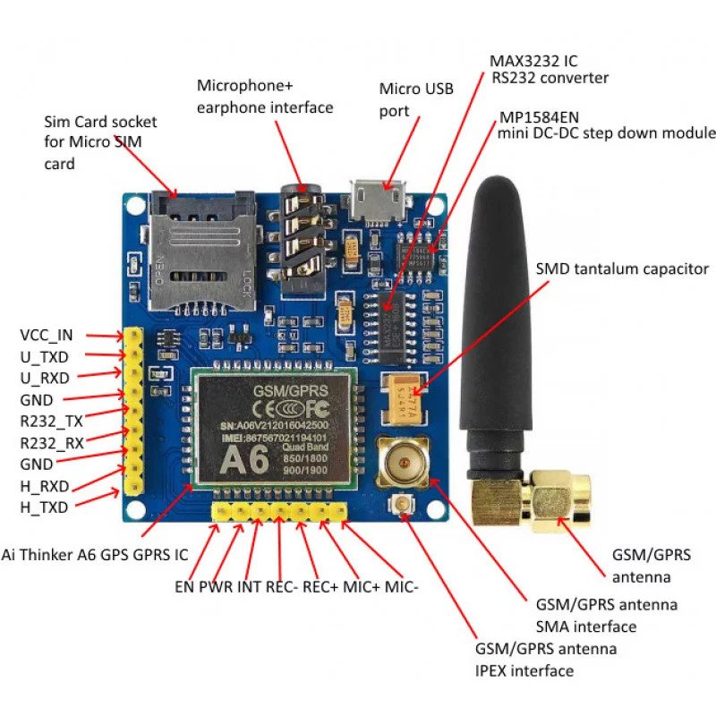

**Fig 7:** SIM900A GSM/GPRS Module Components

A 4.0V power source capable of delivering up to 2A of current powers the module. Any voltage above 4.5V will destroy the module, thus use caution. The UART Interface is used to communicate with this module. The UART interface is used to send and receive data to and from the module. So we may use just two wires to connect with your controller, such as an NodeMCU, Arduino, AVR, or Raspberry Pi.

### 7.4. TTP223 Touch Sensor Module:

The TTP223 touch sensor module can be used as a touch input with microcontrollers such as ESP8266. It can be used to replace the inconvenient push buttons with touch pads, and it is very simple to use. The TTP223 IC is used in the module to detect touch on a capacitive pad [16].

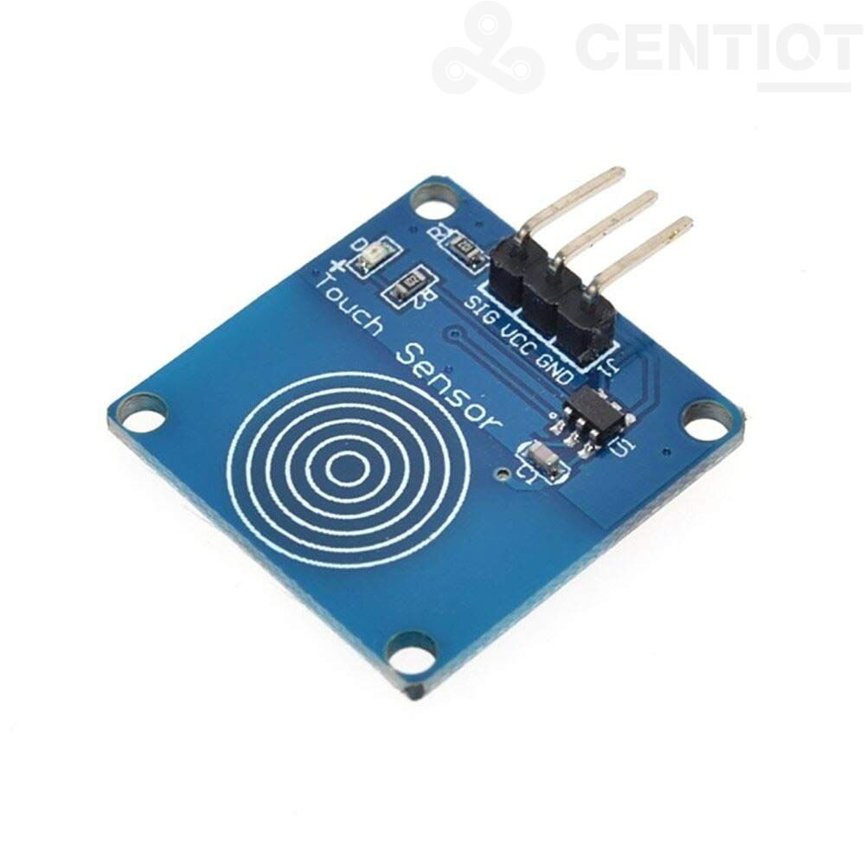

**Fig 8:** TTP223 Touch Sensor Module

**Technical Specifications of TTP223 Touch Sensor Module:**

* Operating Voltage: 2V - 5.5V
* No. of channel: 1
* High Output: 0.8*Vcc
* Low Output: 0.3*Vcc
* Response time: 220mS

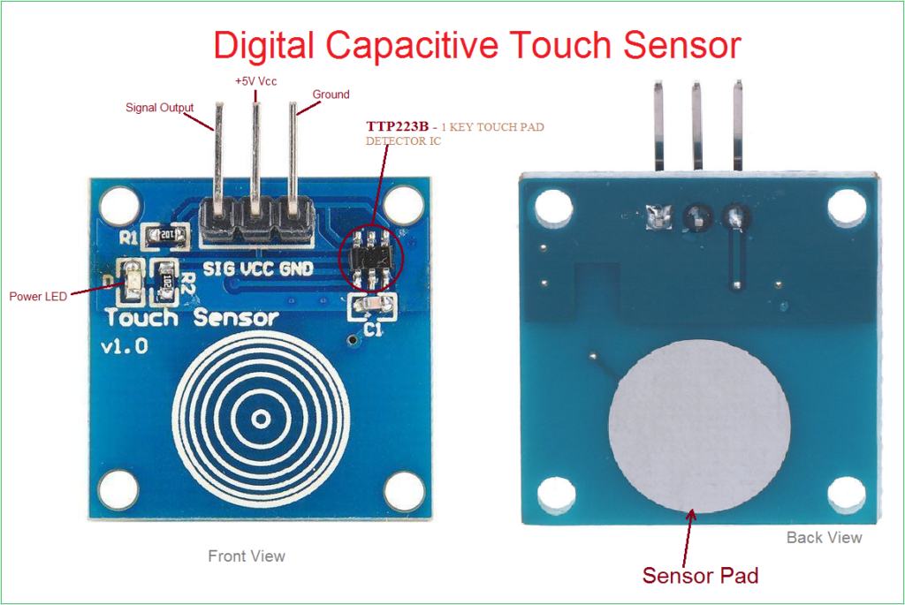

**Fig 9:** TTP223 Touch Sensor Module Components

**8. SOFTWARE**

­The ESP8266 NodeMCU Development Board is programmed using the Integrated Development Environment (Arduino IDE). The firmware flashed to the board has the main segments,

1. **Fetching** the valid sets of coordinates of the current location by GPS Module,
2. **Triggering** the system by touching the Touch Sensor,
3. **Responding** the trigger by sending an SMS to a registered mobile number with the location details with a Google Map Link.

The algorithm of the whole system is described below as a flowchart.

When the system is powered ON, the GSM and GPS modules are initialized. The GSM module is incorporated with a SIM card and the module gets connected with the corresponding cellular network of the particular mobile number of the SIM card. The GPS module is made up of tiny processor and antenna that receive data directly from satellites via specific radio frequencies. So, the GPS module keeps getting the data from the satellite continuously and the module is interfaced with the microcontroller unit, where in the memory that data gets stored.

When the user touches the touch-pad of the touch sensor, the sensor gives a high signal in the corresponding pin of the ESP8266 microcontroller, and then the GSM module is used to send a response. The microcontroller provides the Google Map link with proper location coordinates, along with a warning message as the content of the SMS. The GSM sends the warning message along with the Google Map link in the form of a SMS to a particular registered mobile number.

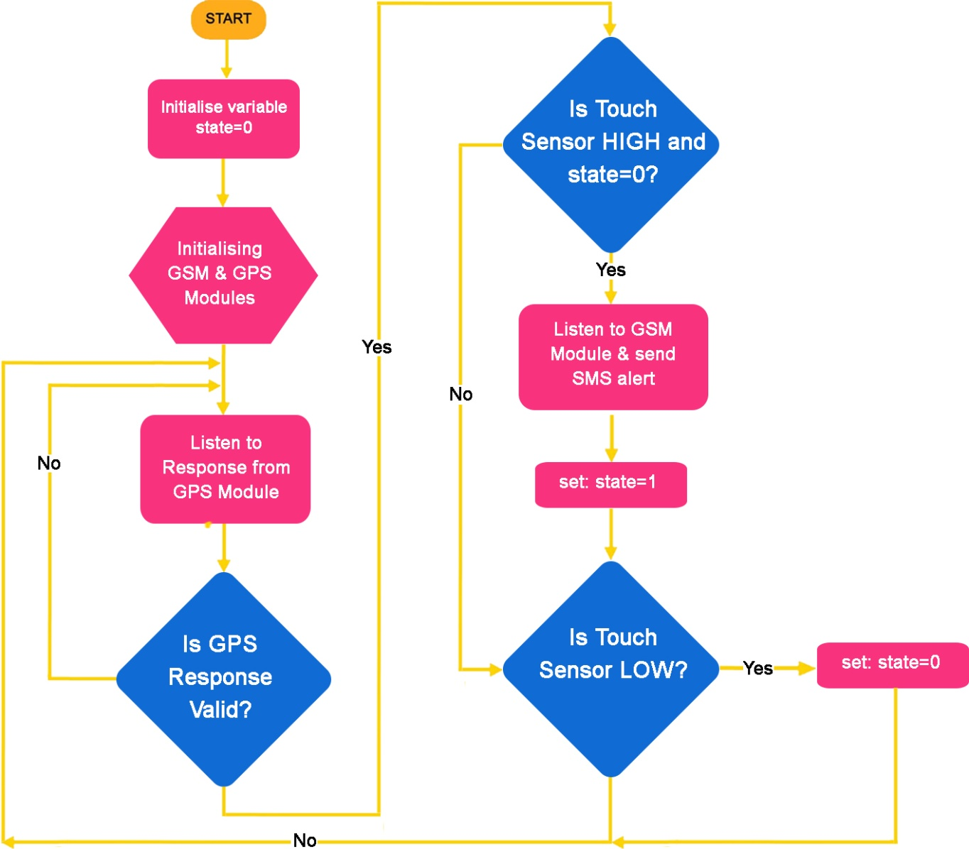

**Fig 10:** Flowchart of algorithm used in Res-TrackR

**9. DEPLOYMENT AND RESULTS**

So, here in the Res-TrackR system we use GPS module in order to fetch the location coordinates directly from the satellite and the GSM module to send a SMS as an alert along with the Google Map link of the current location of the device.

The GPS module constantly supplies the location latitudes and longitudes to the microcontroller (ESP8266) which get stored in the memory of ESP8266 unit.

The implementation of the system is shown with the following block diagram:

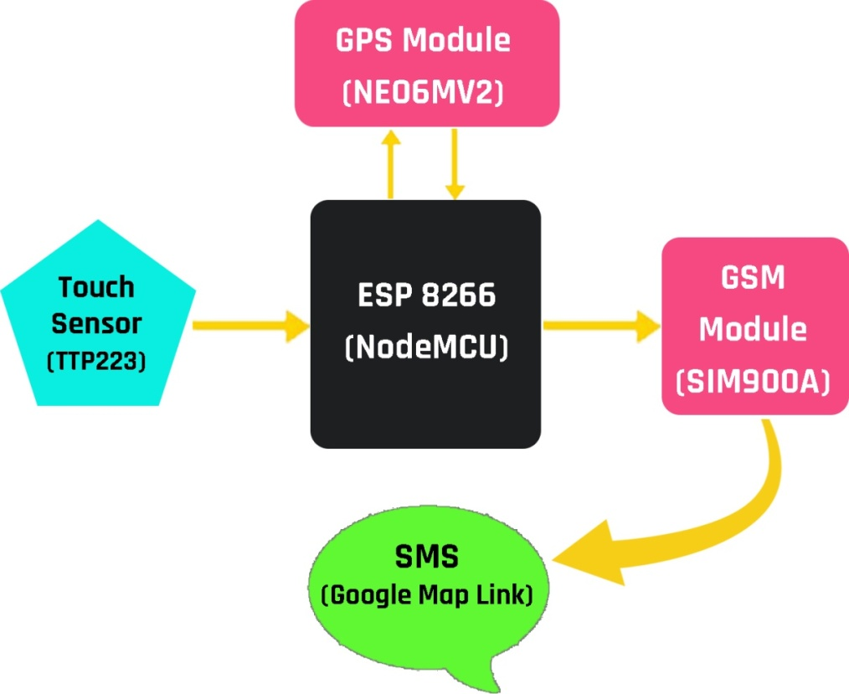

**Fig 11:** Deployment Model of Res-TrackR

Now, when the user is in trouble and wants to share the current location, then the system is to be powered ON and the user should touch the touch pad of the sensor in the device to create a trigger in the system. As soon as the microcontroller gets the HIGH input or trigger from the Touch sensor, it enables the GSM module to send an SMS to a registered mobile number with the alert message and a Google Map link URL with the current location coordinates. The person in the receivers end just need to click on the link or URL given in the SMS to track the actual position of victim at the time of triggering the device.

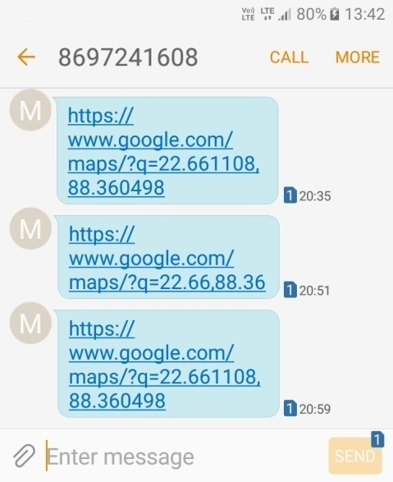 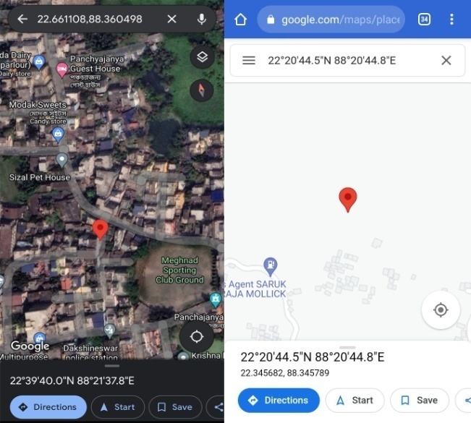

**Fig 12: (a)**SMS sent by GSM with Google Map Link (b)Google Map view of the location

**10. FUTURE SCOPE**

There are several future works and improvements for the proposed system,

* System can be embedding smaller size system which can be placed on body with comfort which will enhance woman safety.
* Camera and microphone feature can be implemented in the advanced system.
* By using this we can capture the images and record the audio of the person, who are in trouble and these information will transmitted by using the GSM & GPS modules.

People can use this device in remote areas as well as internet connectivity is being established by satellite. So, even if there is poor cellular network, using API call we can perform the same task. Also, this system can be modified and used for vehicle tracking. Similarly, people can use this device in deep forests, impassable hill areas etc. where people can be stuck, for faster and easier rescue operations.

**11. CONCLUSION**

The proposed design will deal with critical issues faced by women and will help to solve them with technologically sound equipment and ideas. Being safe and secure is the demand of the day. By using this system we can reduce the crime rate against the women. Women’s security is a critical issue in current situation. The crimes can be reduced with the help of real time implementation of our proposed system. This system can provide the mechanism to track the vehicle which will be very helpful for working women also. This will make her journey safer and secure. Without women's progress, a country cannot move forward, yet we see women suffer a lot for harassment on their way, which is a hindrance to their progress. The main benefit of using this safety system is that women can feel confident when they go outside as they can quickly get support through the system when they are in danger.

So, the device achieved what it was aiming. The location was successfully tracked down and with the help of GSM, appropriate help can be sent on time and the suspect can also be tracked down ensuring complete safety and security of the woman. Finally, it can be said that this device will serve as a protection charm for women.

**REFERENCE**

|  |  |
| --- | --- |
| 1. | Sathyarsi, B., Jaishree Vidhya, U., Jothi Sree, G. V. K., Pratheeba, T., Ragapriya, K. : Design and Implementation of Women Safety System Based On Iot Technology, IJRTE, Vol 7 (2019) 177-181. |
| 2. | Dr. Dave, S., Singh, V., Singh, V., Kumawat, V. : WOMEN SAFETY DEVICE BASED ON GPS & GSM, IJEAST, Vol 5 (2020) 197-201. |
| 3. | Choudhary, Y., Upadhyay, S., Dr. Jain, R., Chakraborty, A. : WOMEN SAFETY DEVICE, IJARSE, Vol 6 (2017) 413-421. |
| 4. | Latha, K., Vinay Kumar, G., Naveen, P., Srikanth, B., Vijay srinivas, K. : Women safety and security system using GSM and GPS, IJCRT, Vol 8 (2020) 4618-4622. |
| 5. | Srinivasan, K., Navaneetha, T., Nivetha, R., Mithun Sugadev, K. : IoT Based Smart Security and Safety System for Women and Children, IRJMT, Vol 2 (2020) 23-30. |
| 6. | Kale, N., Hadke, K., Kadam, M., Nale, K. : WOMEN SAFETY DEVICE WITH GPS, GSM AND HEALTH MONITORING SYSTEM, IRJET, Vol 8 (2021) 3616-3619. |
| 7. | Dr. Gomathy, C. K., Mr. Lakshmi Kartheek Kumar Reddy, R., Mr. Sai Krishna Chaitanya, S. : WOMEN SAFETY BASED ON GPS CONTROL, IRJET, Vol 8 (2021) 253-259. |
| 8. | Engr. Nkem, N., F. : Implementation of Car Tracking System using GSM/GPS, IJSRP, Vol 10 (2020) 399-403. |
| 9. | Yekini, N., A., Oloyede, A., O., Agnes, A., K., Okikiola, F., M. : Microcontroller-Based Automobile Tracking System with Audio Surveillance using GPS and GSM Module, I. J. IEEB, Vol 3 (2016) 41-46. |
| 10. | Kumar, J. S., Sreelakshmi, D., Bhargavi, G., S. : WOMEN SAFETY SYSTEM USING GSM & GPS TRACKING, JETIR, Vol 5 (2018) 1157-1160. |
| 11. | Chinwike, M., N., Ozuomba, S., Archibong, E., I., Ekott, E., E. : Development Of Microcontroller-Based Tricycle Tracking Using Gps And Gsm Modules, JMEST, Vol 7 (2020) 13587-13591. |
| 12. | Tummanapally, S., S., Sunkari, S. : Smart Vehicle Tracking System using GPS and GSM Technologies, SSRN (2021). |
| 13. | ESP8266EX Datasheet Version 4.3 Espressif Systems IOT Team http://bbs.espressif.com/ Copyright © 2015. |
| 14. | NEO-6 u-blox 6 GPS Modules Data Sheet. |
| 15. | SIMCom Hardware Design SIM900A_HD_V1.01. |
| 16. | https://quartzcomponents.com/products/ttp223-based-capacitive-touch-sensor-module. |